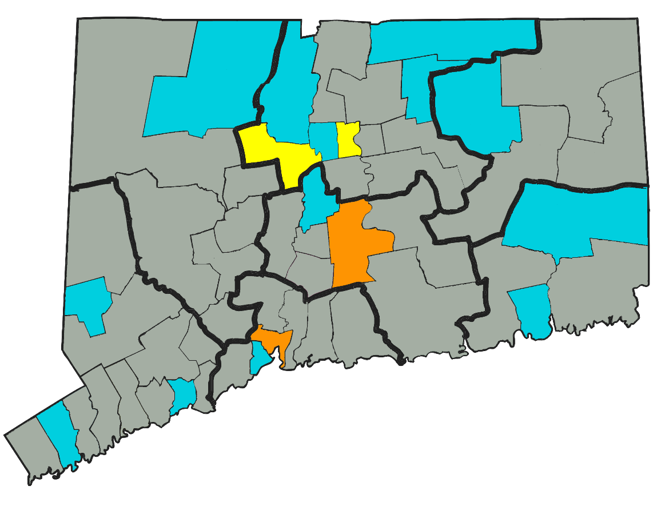

Connecticut’s Forced Electroshock Problem
Unpacking forced electroshock data obtained from the State of Connecticut Office of the Probate Court Administrator.
By Jim Flannery | November 21, 2025

Earlier this year, a bill was proposed in the State of Connecticut to end forced shock treatment. To put it mildly, the bill restored my hope.
Since my first encounter with involuntary psychiatric treatment in Hartford, Connecticut back in 2008, I dreamt of a world free from all forms of forced mental health services. My later introduction to the psychiatric survivor movement in 2017 brought awareness of an effort born in the early 1970’s that, at least, delivered the legal changes to state laws around the U.S. that still give us the right to a legal hearing prior to being involuntarily drugged and/or electroshocked. To me, the existence of these hearings represented a tangible artifact of progress toward an ultimate end. The impossible was possible.
In comparison, my personal efforts to realize the fantasy have largely fallen flat, at times seeming only to further perpetuate the negative stereotypes of a labelled person. And, admittedly, the ambitious dream — of one day witnessing the finale to forced psychiatry without ever even imagining that the first act could be the conclusion to forced shock in the very state I was born — was a naïve one, which eventually seemed to have left me forever hopeless in the absence of any evidence of victorious progress.
Learning that my own home state of Connecticut was considering abolishing forced electroshock was a wake up from the child-like dream world turned nightmare, and into a reality where the first act was already underway.
Hope seemed to return.
Sadly, the deadline for the bill to be put out for public testimony uneventfully rolled by, quickly leaving me wondering whether the bill itself had been nothing more than a dream.
As one does… I reported to clown duty at Hartford, Connecticut’s Bushnell Park, where I spoke with many Connecticut residents about the state’s forced electroshock laws. After convincing people that it was, in fact, really legal to perform electroshock treatment on someone against their will, most responded with some version of “well, just because it’s legal doesn’t mean they actually do that to people.” Without having a law that I could point to (C.G.S. § 17a-543(c)) or being able to tell them I’m an electroshock survivor myself (I’m not), I didn’t really have the answer people deserved.
In search of hard data, I began writing to the probate courts and found my answer surprisingly quickly from the State of Connecticut Office of the Probate Court Administrator, which provided the district-by-district data showing just how many petitions were filed by mental health facilities in Connecticut requesting permission from the probate courts to perform forced electroshock on people.
The heartbreak of seeing the data for the first time was only made worse by the uncomforting enthusiasm of wanting more – to sum up the probate district shock petition numbers for each year and visualize the data for the entire state as a graph. (Yes, “uncomforting enthusiasm” is the best euphemism I can come up with to describe the feeling without providing you with the ability to relate to the absolutely disgusting sensation of being excited about possessing high-quality tragic data.)
Without further adage, the state-wide data graph showing the number of forced electroshock petitions filed to probate courts by mental health facilities throughout Connecticut from 2012 to 2024:
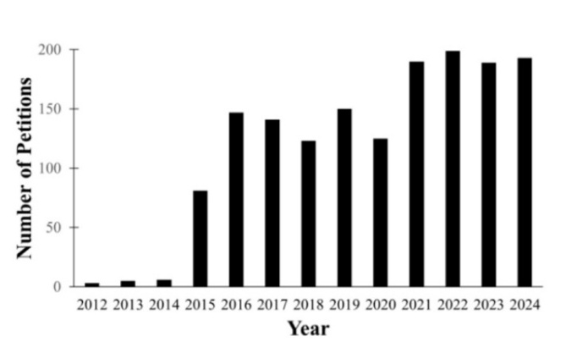
Forced electroshock requests filed to state probate courts by mental health facilities in Connecticut between 2012 and 2024.

The need to know the underlying story my eyes were inhaling led to creating a timelapse map of the data by probate district:
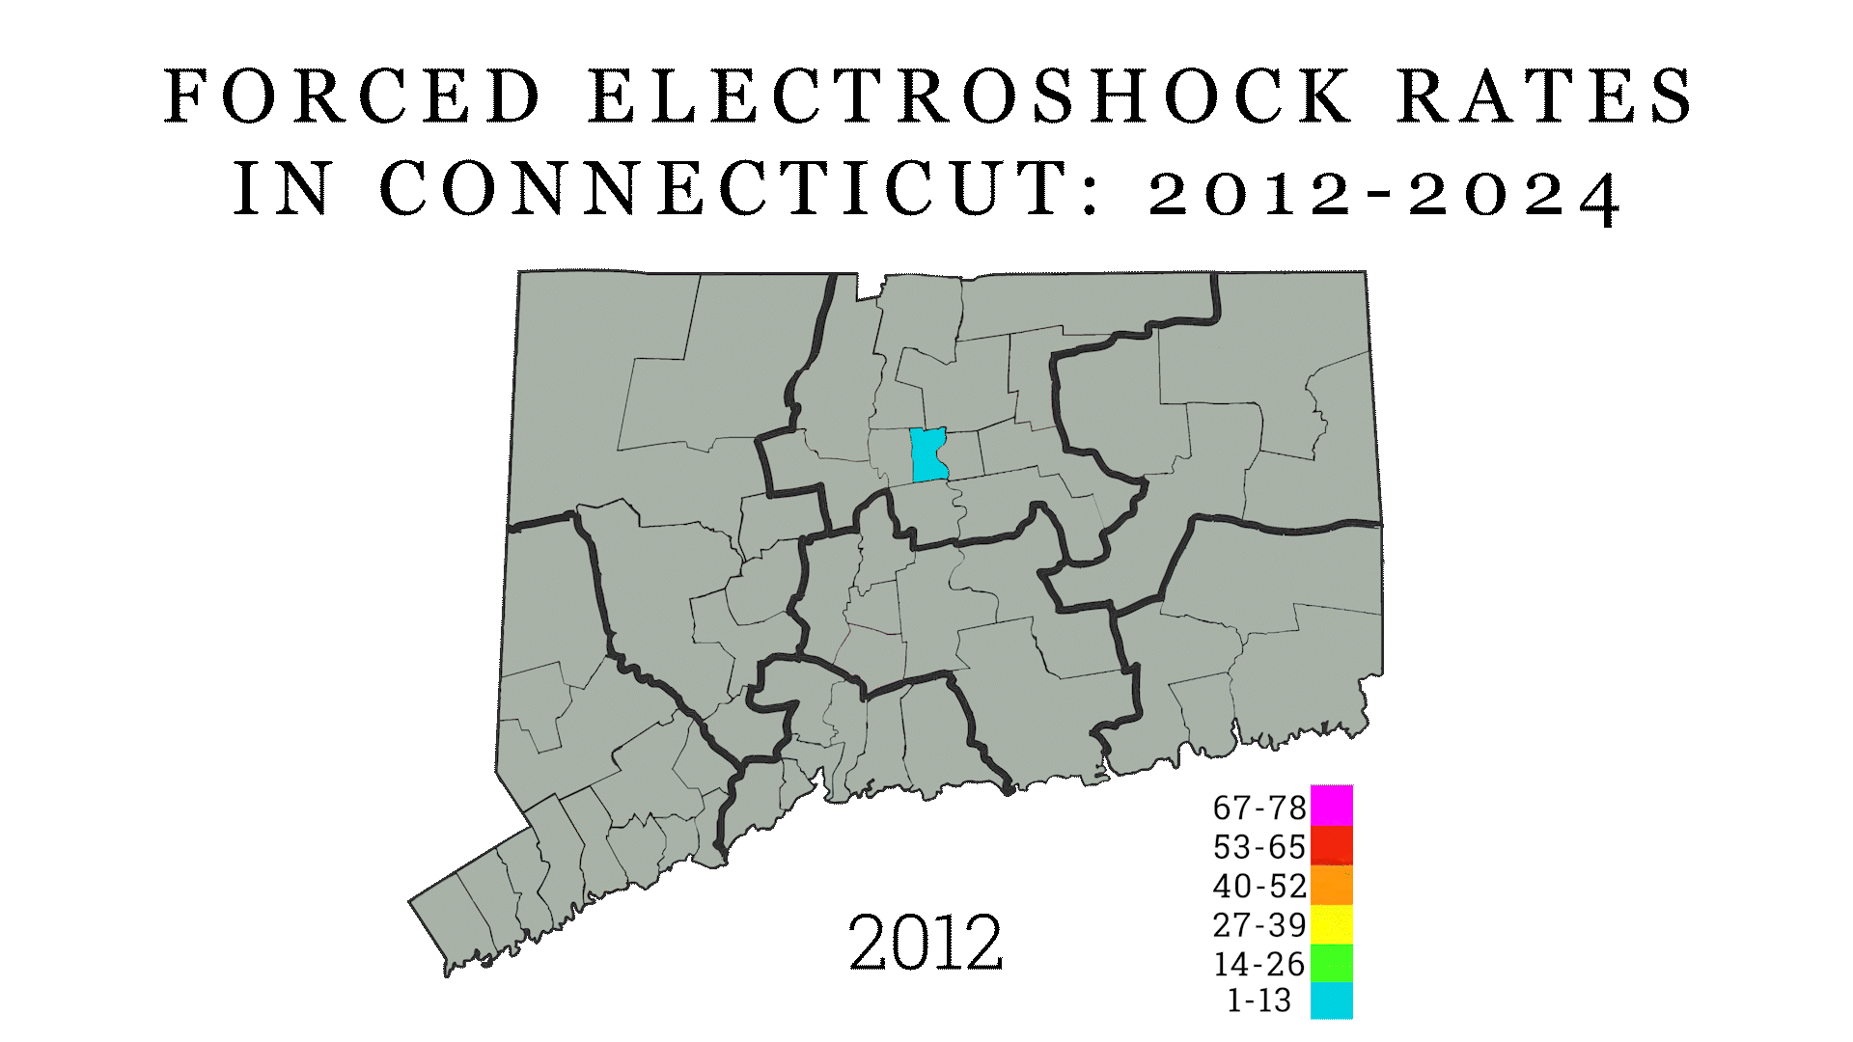
Rate at which forced electroshock requests were filed to state courts by mental health facilities throughout Connecticut between 2012 and 2024 (by probate district).

After shaking off the disturbance of legalized human torture visualized in color, you may be left with the same two questions that I have:
- Why was there such a big increase in 2015?
- Why have the numbers continued to increase?
I can only say: “I don’t know.”
My hypothesis: forced shock is simply growing by word of mouth and what we are seeing here is not the result of a law being changed or under-reporting, but instead it’s just geographical; we’re watching the decision to use forced electroshock spread from Hartford to its neighbors in Manchester and Waterbury, become adopted over at Connecticut Valley Hospital and Whiting Forensic in Middletown, and then spread down to New Haven and across the state.
It doesn’t look good.
And I don’t have the answer.
Hence my reason for writing; to at least share what I’ve found thus far in hopes you may know the answers.
If it helps:
- Graphs for “The Big Four”
- “Percy A. Monty Dies; Retired Army Officer”, Hartford Courant, February 25, 1976

